Welcome Home Veterans!

Just be cautious with the junk mail
GEORGE W KRUSE

OCT 12

READ IN APP

People often ask me whether this job as a commissioner is worth it. My answer usually depends on the day I’m asked. On a day like Tuesday, it’s a resounding YES.
On Tuesday, the BOCC voted unanimously to conveyed county-owned land to Tunnel to Towers (T2T) for the construction and operation of a 122-unit permanent housing complex focused on our homeless and under-housed Veterans. Once completed, the property will be managed by T2T with extensive wrap-around services overseen by U.S. Vets.
To see the full discussion, complete with public comment, the video is below. The heart of the video is at the very beginning when Tunnel to Towers VP Gavin Naples gives his presentation on both the proposed project and the correction of misinformation that has been floated around.
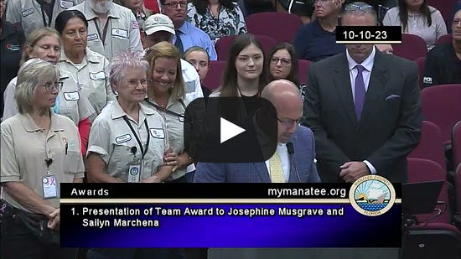
This is a long overdue vote on the fulfillment of a promise the BOCC made long ago when allocating $15MM of American Rescue Plan funds to housing our Veterans. This proposal began way back in May 2022 when I was able to get a list of service providers from the Congressional Chairman of Veteran Affairs on a trip to DC. That resulted in connecting with CEO Steve Peck of U.S. Vets who introduced me to Tunnel to Towers. Once T2T and U.S. Vets came to Manatee County in August 2022 to assess site options and the needs of the County, our staff took over and they have been working diligently ever since to see this to fruition.
The future Tunnel to Towers Veteran Village will provide both apartment-style units and individual “comfort” home accommodations on an expansive, low-density site in close proximity to transit, employment opportunities and services. The property will provide all levels of services and care to help our Veterans get back on their feet and into more-permanent residences. This is truly a win for Manatee County. We are bringing in a best-in-class provider at a fraction of the anticipated cost to taxpayers for services well above what we could have ever envisioned.
Thank you Tunnel to Towers and U.S. Vets for sticking with us, engaging the public and providing for our Veterans, both here in Manatee County and nationwide!
If you would like to donate to either of these highly-rated nonprofits, I’ve included the links below:
Tunnel to Towers
U.S. Vets

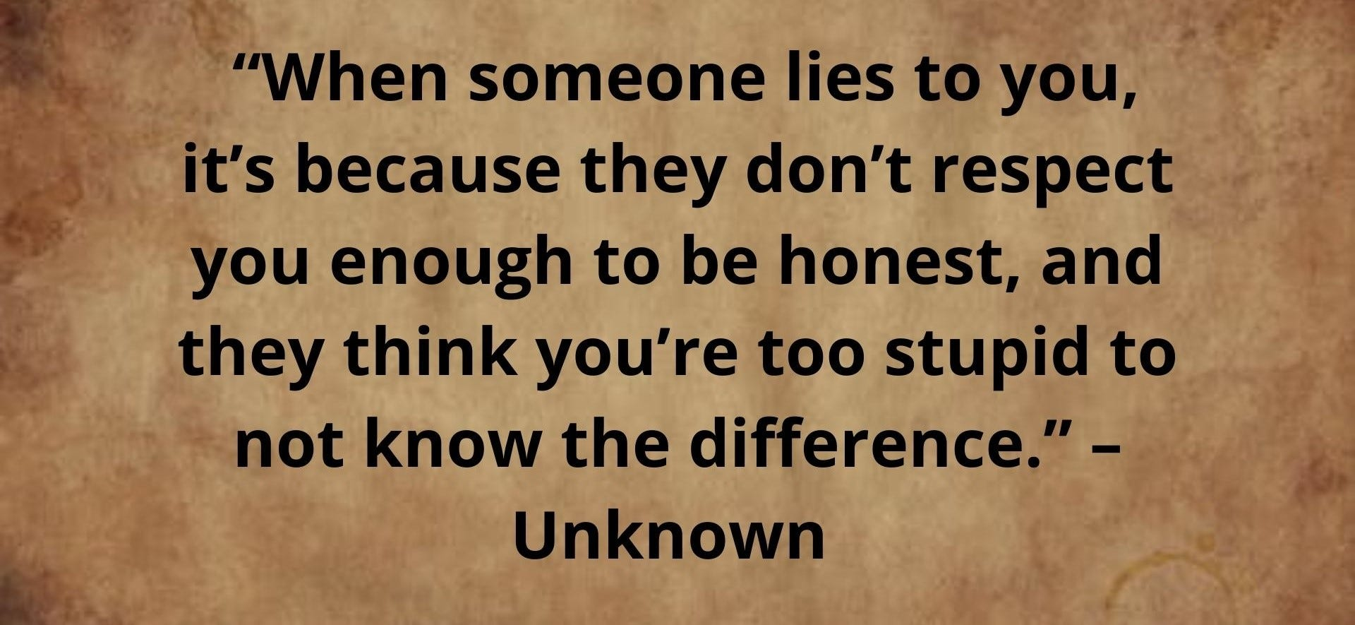
However, this successful vote was not without its delays and outside influences. This is Manatee County after all.
After a lengthy delay, by tabling the vote in August, a full-court press was put on in an attempt to sway community support away from this great opportunity for our Veterans. It started with town halls being presented as discussions about “homeless shelters” and culminated this past week with a disingenuous propaganda campaign being waged across any and all forms of media and outreach.
* They don’t care if your neighborhood is actually safe as long as their nearby investments are.
Neighbors were warned of “Commissioner George Kruse's latest plan gives away $6 million in taxpayer lands to a New York developer so they can build a homeless shelter next door to our neighborhood.” via multiple unsolicited text messages.
They doubled down on the “homeless shelter” references and alerted community members via their mailboxes of violent crimes, homeless camps and drug/alcohol use. They wanted to warn you that our Veterans, who fought for our freedom, would assault or KILL you if they’re allowed to move into your neighborhood.
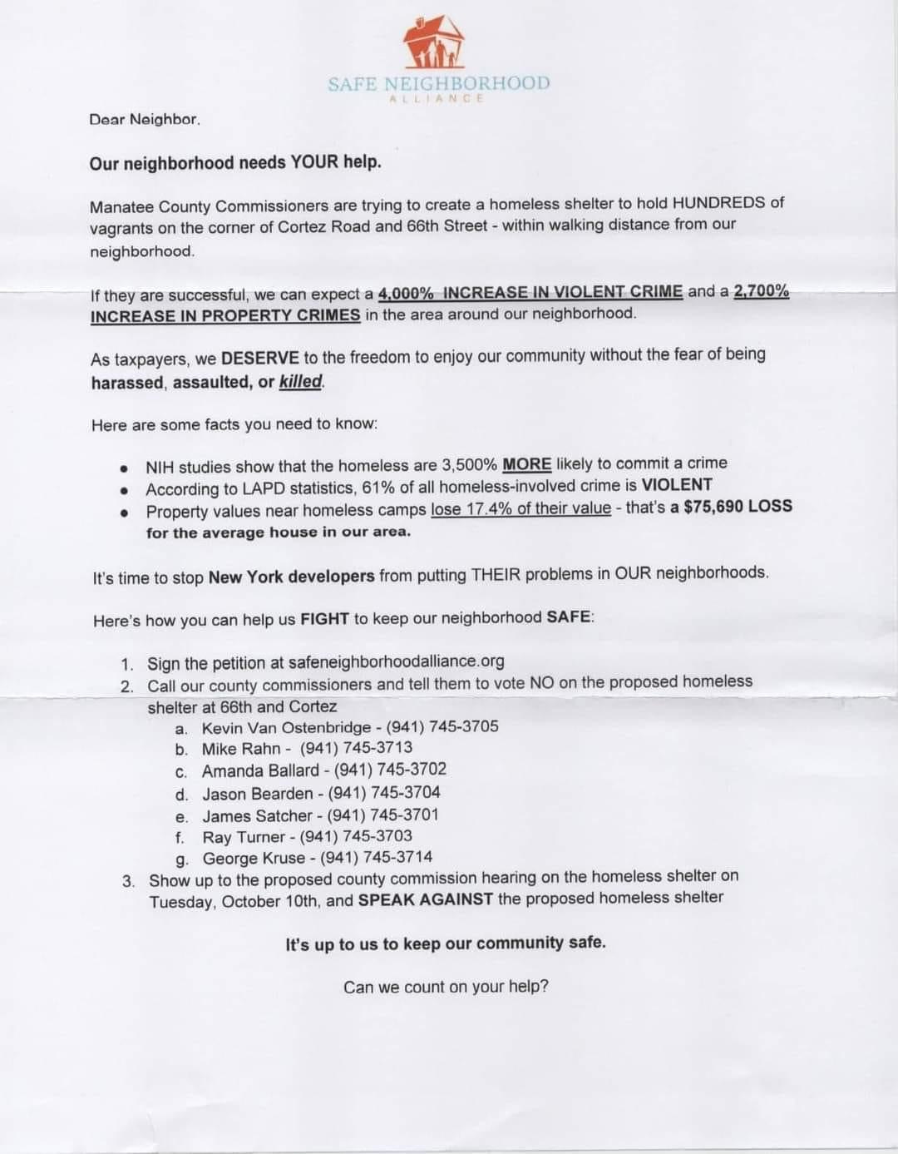
This is what happens when people with more money than morals believe they should, and must, always get their way.
They willfully put their own self-interests ahead of the interests of our worthy Veterans. It’s despicable and, quite honestly, pathetic. However, they believed it would work…because every two years, to get their way, it has worked in the same manner.
Many of those receiving these texts and envelopes came to the realization that they were being flat-out lied to and deceived once they learned what was really being proposed.
Unfortunately, after the wetlands policy attacks and now the attacks on housing for Veterans, it now appears that campaign-style propaganda and lies are going to expand into day-to-day policies of this board and the community.
Fortunately, you are all catching on.
LIKE |  | COMMENT |  | RESTACK

© 2023 George W Kruse
1112 Manatee Avenue West, Bradenton, FL 34205
Unsubscribe

